EEECS Summer Research Internships
School of Electronics, Electrical Engineering and Computer Science
Internships Summer 2026
Proposed Project Title: SideChannelSleuth: Breaking the ASCON with the Rainbow simulation tool
Principal Supervisor: Ayesha Khalid
Project Description:
Imagine playing the role of a digital detective, hunting for invisible clues of sensitive information leaked by computer chips. That is the core of this internship! As our everyday devices become smarter, they rely on "lightweight" security locks (or algorithms) like the ASCON cryptography algorithm to keep our data safe. But what if the physical hardware accidentally whispers its secrets while running these locks? As lightweight cryptographic algorithms are increasingly deployed on simple, low-cost embedded devices, ensuring they are secure against physical attacks is highly critical.
This internship would provide a valuable learning experience for the student, as they would learn to install and use the Rainbow simulation toolchain on their laptop, implement ASCON algorithm, and attempt simulated attacks to understand cryptographic leakage.
The Rainbow tool—a side-channel analysis simulation tool developed by Rainbow Donjon [1] —can simulate and analyze side-channel attacks against cryptographic algorithms, including ASCON that is a prominent lightweight cryptography algorithm, recently standardized by National Institute of Standards and Technology, NIST in the USA) [2].
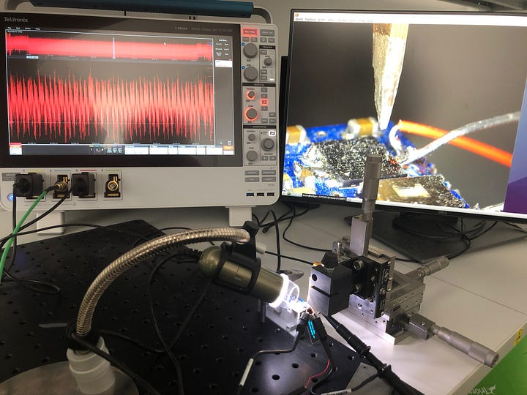
Figure 1 A typical side-channel analysis equipment and setup needed for attacking lightweight cryptography on embedded devices, not necessarily cheap. Rainbow donjons helps avoid the hardware setup via their simulation tool

Objectives:
This project will give you confidence in working with new technologies and tools, enhancing your problem-solving skills and your understanding of security. You will learn traits that can lead to a potential career path in future, i.e., effective documentation and analysis of your findings related to the project, develop communication and presentation skills, learn how to work effectively within a professional team, etc.

Some technical objectives are listed below:
- Learn and appreciate the importance of cybersecurity in modern engineering projects and learn basic cryptography algorithms including ASCON along the way.
- To gain practical experience of working with the side channel analysis via the Rainbow simulation tool emulated on an ARM Cortex M0 device. The student will simulate side-channel attacks on ASCON to uncover its physical security vulnerabilities. The student will get a chance to explore the specific conditions and optimizations that affect ASCON's resistance to side-channel attacks.
- Throughout the project, the student will systematically document and analyze their findings, develop communication and presentation skills, and learn to work effectively within a professional team.
References:
[1] https://www.ledger.com/introducing-rainbow-donjons-side-channel-analysis-simulation-tool

[2] Ascon-Based Lightweight Cryptography Standard https://csrc.nist.gov/News/2025/nist-publishes-sp-800-232
Academic Requirements:
The scheme is open to EEECS Undergraduates in BSc/Beng/Meng Computer Science and Software Engineering. A minimum current average classification of 65% average required, higher average classification will be recommended and used as part of the ranking criteria.
General Information:
Supervisor Name: Ayesha Khalid

Address:

Queen’s Titanic Quarter
Northern Ireland Science Park
Queen's Road, Queen's Island
Belfast
United Kingdom
BT3 9DT

Email: a.khalid@qub.ac.uk

